**PROJECT: LIBRARY MANAGEMENT SYSTEM**

**ER DIAGRAM:**

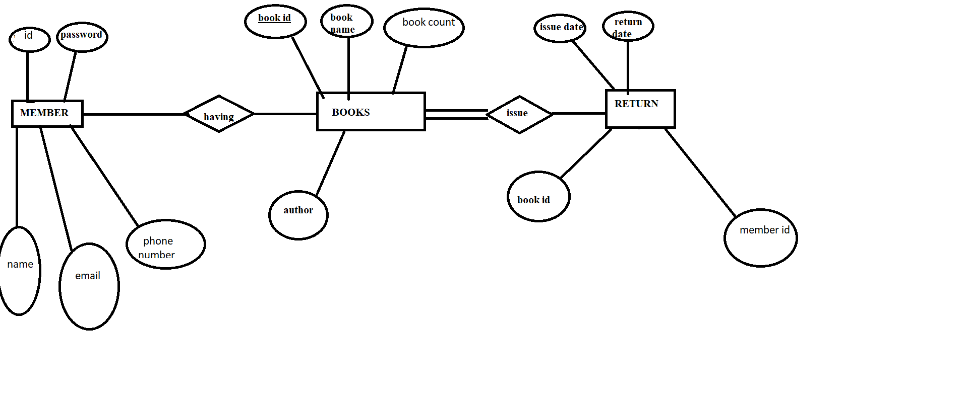

**UML DIAGRAM:**

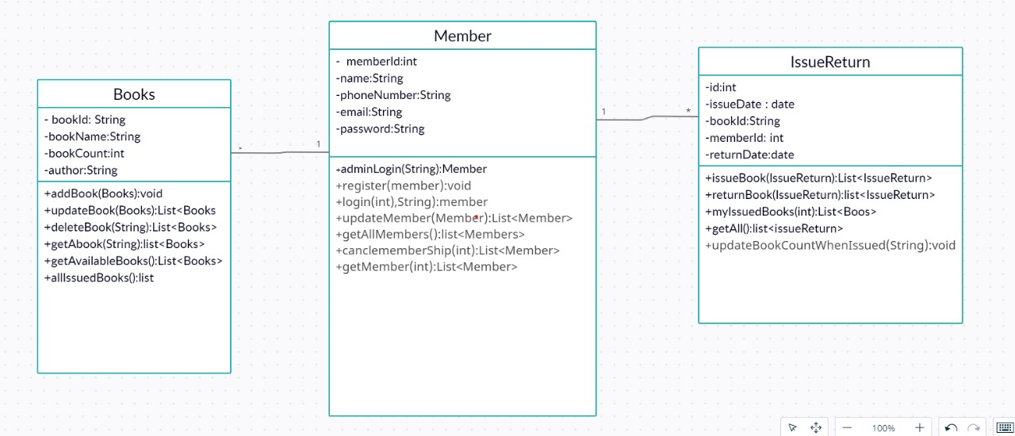

**FRONTEND DEVELOPMENT:**

**DESCRIPTION:**

Library Management System is a software that uses to maintain the record of the library. It contains work like the number of available books in the library, the number of books are issued or returning or renewing the book by the user. It manages and stores books information electronically according to students needs and it helps both students and library manager to keep a constant track of all the books available in the library. It allows both the admin and the student to search for the desired book.

**REQUIRED SPECIFICATION:**

Once the application is loaded the first screen appears as below

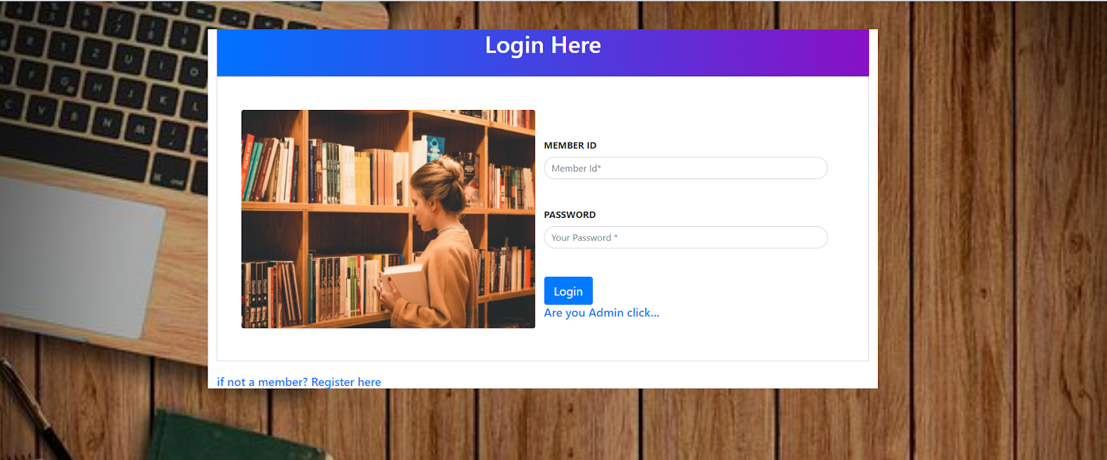

Here the user can enter their **Member Id and Member Password** and can login to the application. If he is a First time user of the library then he can register to the application by clicking on the link “if not a member? Register here”. Then it redirected to the Register Page

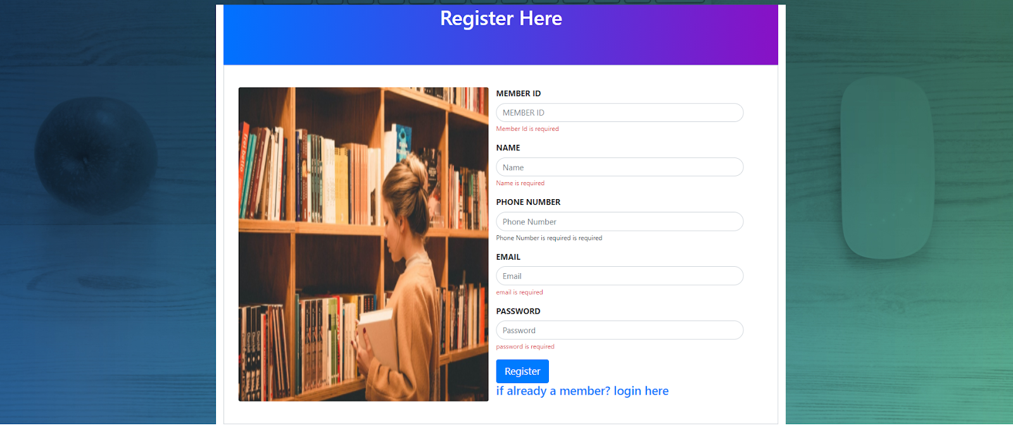

In Register Page, the user can Register by giving the following credentials like

* Name – should contains only String character
* Phone Number- should contains only String character
* Member Id- should contains only String character
* Email- should contains only String character
* Password- should only String character

Now after Register the user can access to the application

If the user is an Admin then he can click on the link “Are you Admin click…” then it will redirect to the Admin Login page

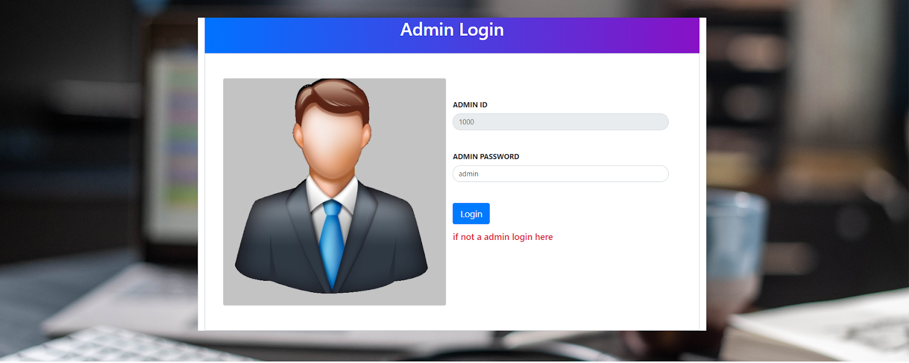

Here the admin can login by entering the credentials and then he will redirect to the admin home page

**ADMIN HOME:**

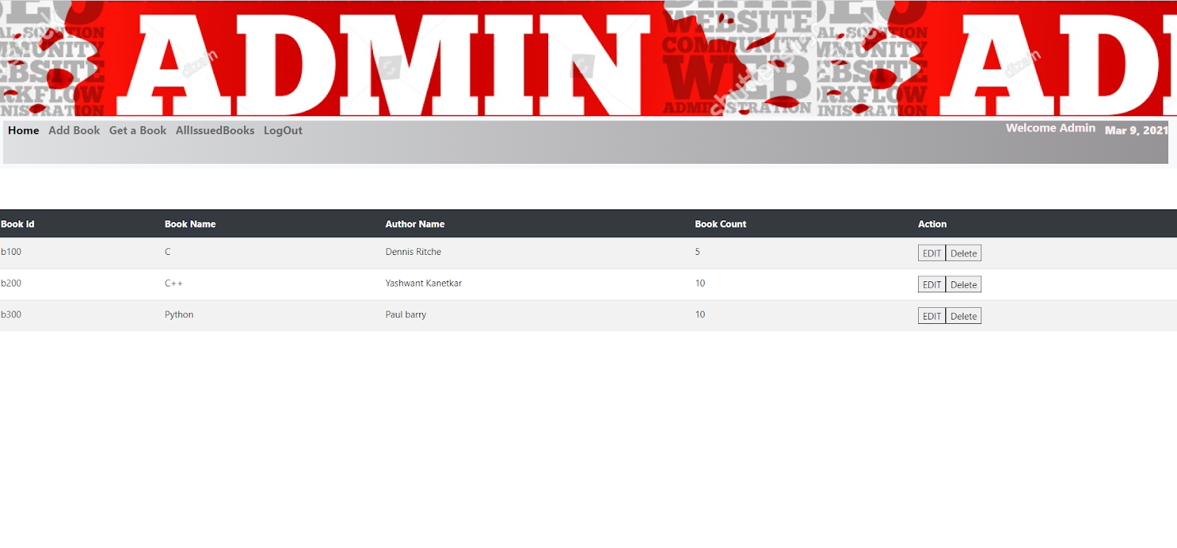

In the Admin Home page, the admin is able to access every routed components in the application

Which performs the following Activities:

* when the admin access the “home tab” then the list of available books appears.
* when the admin access the “Add Book” tab then admin will be redirected to the  add book page where he can add the book by giving the credentials like Book Id, Book Name, Author, Book Count.
* When the admin access the “Get a Book” tab then he will be redirected to the View a book page where he can search a book by giving the book id.
* When the admin access the “logout” tab then admin will be redirected to login page.

In Admin Home page, the admin can see all the list of available books in the library. Admin can also perform curd operations like update and delete a book.

By clicking on the “edit” button, it will be redirected to the “update book” page.

**UPDATE BOOK:**

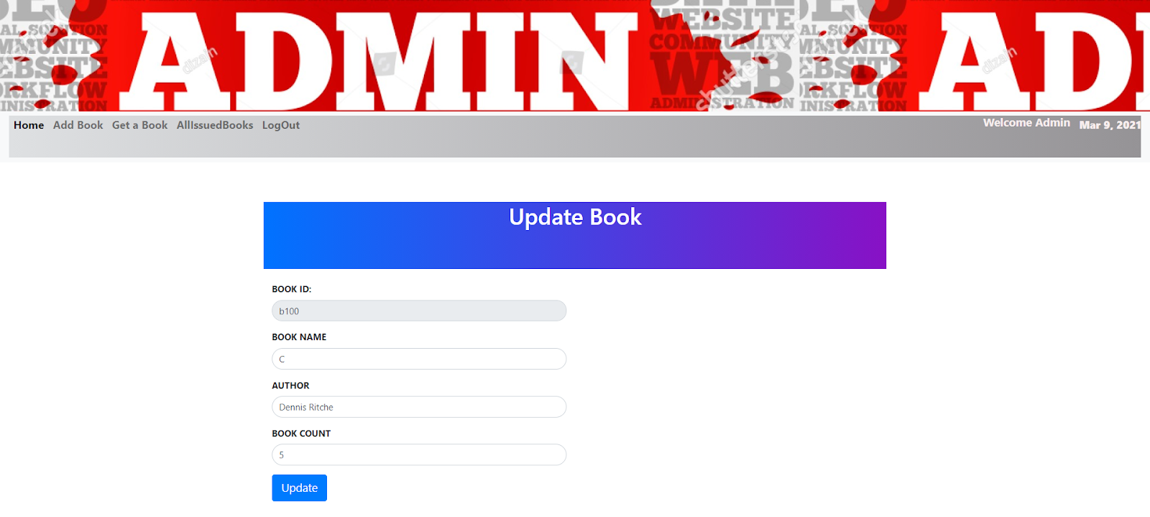

In Update Book, the admin can update the book name, book author, book count but the book Id is fixed

* Book Id- should be of integer type
* Book Name- should contains only String characters
* Author- should contains only String characters
* Book count – should be of integer type

After updating, it will be redirected to the Admin home page and where we can see all the list of books.

**DELETE BOOK:**

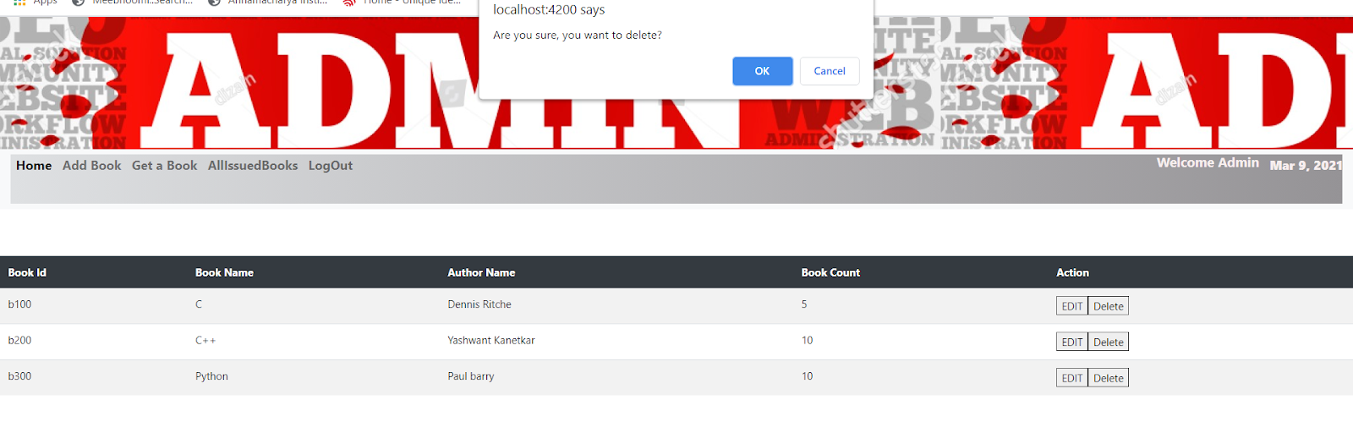

By clicking on the “Delete” button, we will get an alert window

 “Are you sure, you want to delete?” with two buttons “ok” and “cancel”.

By clicking on “ok” the respective book will be deleted.

**ADD BOOK:**

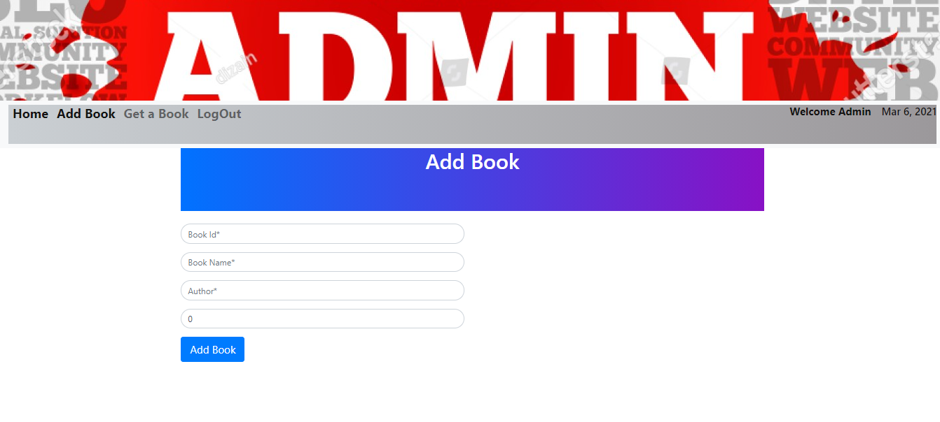

In Add Book, admin can add a book to the library by entering the following details of the book

* Book Id- Should be entered with String characters and digits
* Book Name- should contains only string characters.
* Author- should contains only string characters.
* Book Count- should be of integer type.

By entering the above details the admin can successfully add the book in the library. After adding the book it will be redirected to the admin home page where we can see all the list of books.

**GET A BOOK:**

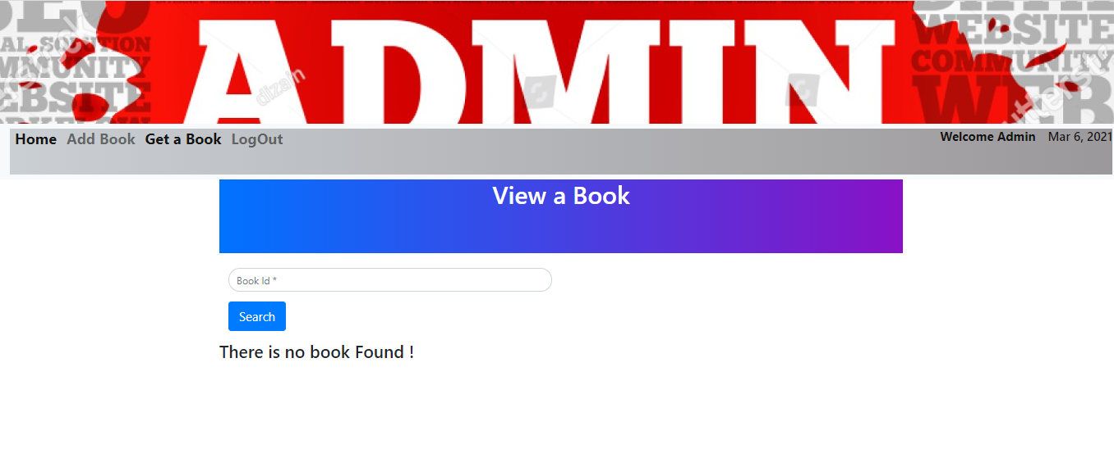

In Get a Book, the admin can view a book by entering the following credentials:

* Book Id:  should be entered with string characters and digits.

Here the admin can search a book by entering Book Id, then by clicking on the “search” button, the particular book details will be displayed.

Before entering the Book Id and also if there is no particular book with that Book Id then “There is no book Found!” message will be displayed.

**LOG OUT:**

When we access the “log out” button the admin can log out and it will be redirected to Admin Login Page

**MEMBER HOME:**

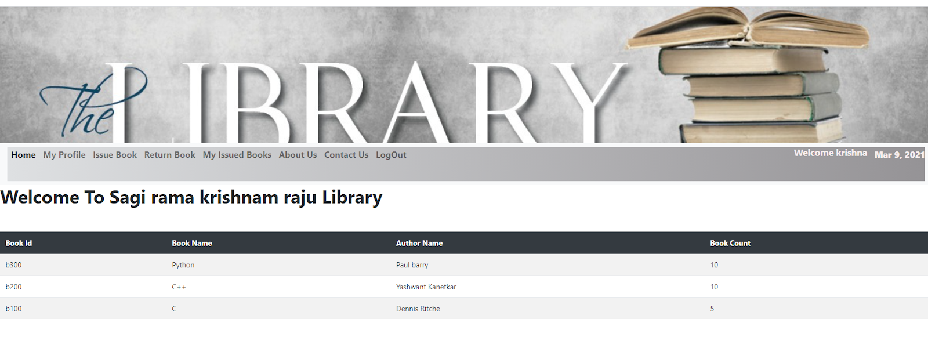

After Member login Page, by entering the correct credentials of the member, it will be redirected to the Member Home Page. In the Member Home page, the member is able to access every routed components in the application which performs the following activities:

* When the member access the “Home” tab, then the member can able to see the list of books which he had already issued.
* When the member access the “My Profile” tab, then the member can see his details.
* When the member access the “Issue Book” tab, then the member can issue a book.
* When the member access the “Return Book” tab, then the member can Return a book.
* When the member access the “About Us” tab, then the information of the library will be displayed.
* When the member access the “Contact Us” tab, then the member get the details like contact number, email of the library.
* When the member access the “logout” tab, then the member can logout.

**MY PROFILE:**

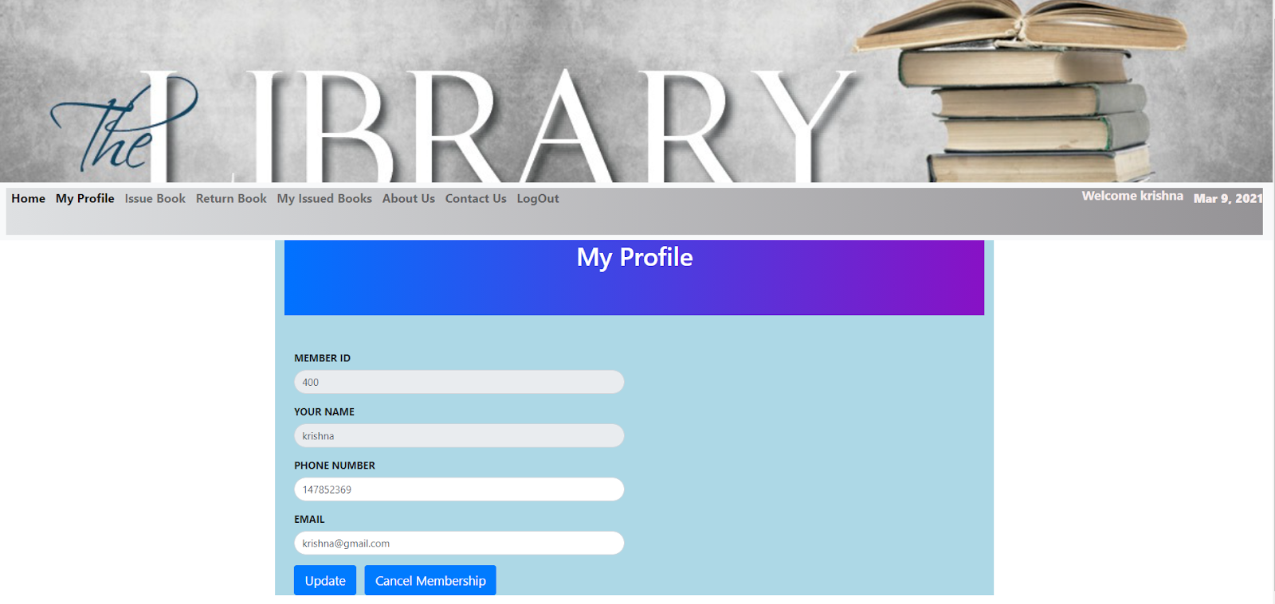

If the member want to update his details, then he can click on the “My Profile” tab then it will be redirected to the My Profile Page, where the member can update the details like member name, phone Number, Member Email

* Name: It should contains only string characters.
* Phone Number: It contains digits.
* Member Email: It contains both string characters and also integer.

**UPDATE:** After entering the details and then by clicking on this button the member details will be updated.

**CANCEL MEMBERSHIP:** A member can  cancel his membership by clicking on this button.

**ISSUE BOOK:**

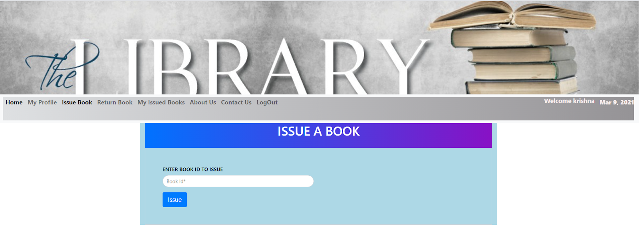

If a member wants to issue a book then he can click on the “Issue Book” tab then it will be redirected to the issue book page. For issuing a book, the member has to enter the following credentials:

* Member Id: It should contain only digits
* Book Id: It contains both string characters and also digits

After entering the member id, book id, the member can issue a book by clicking on the “Issue” button

**RETURN BOOK:**

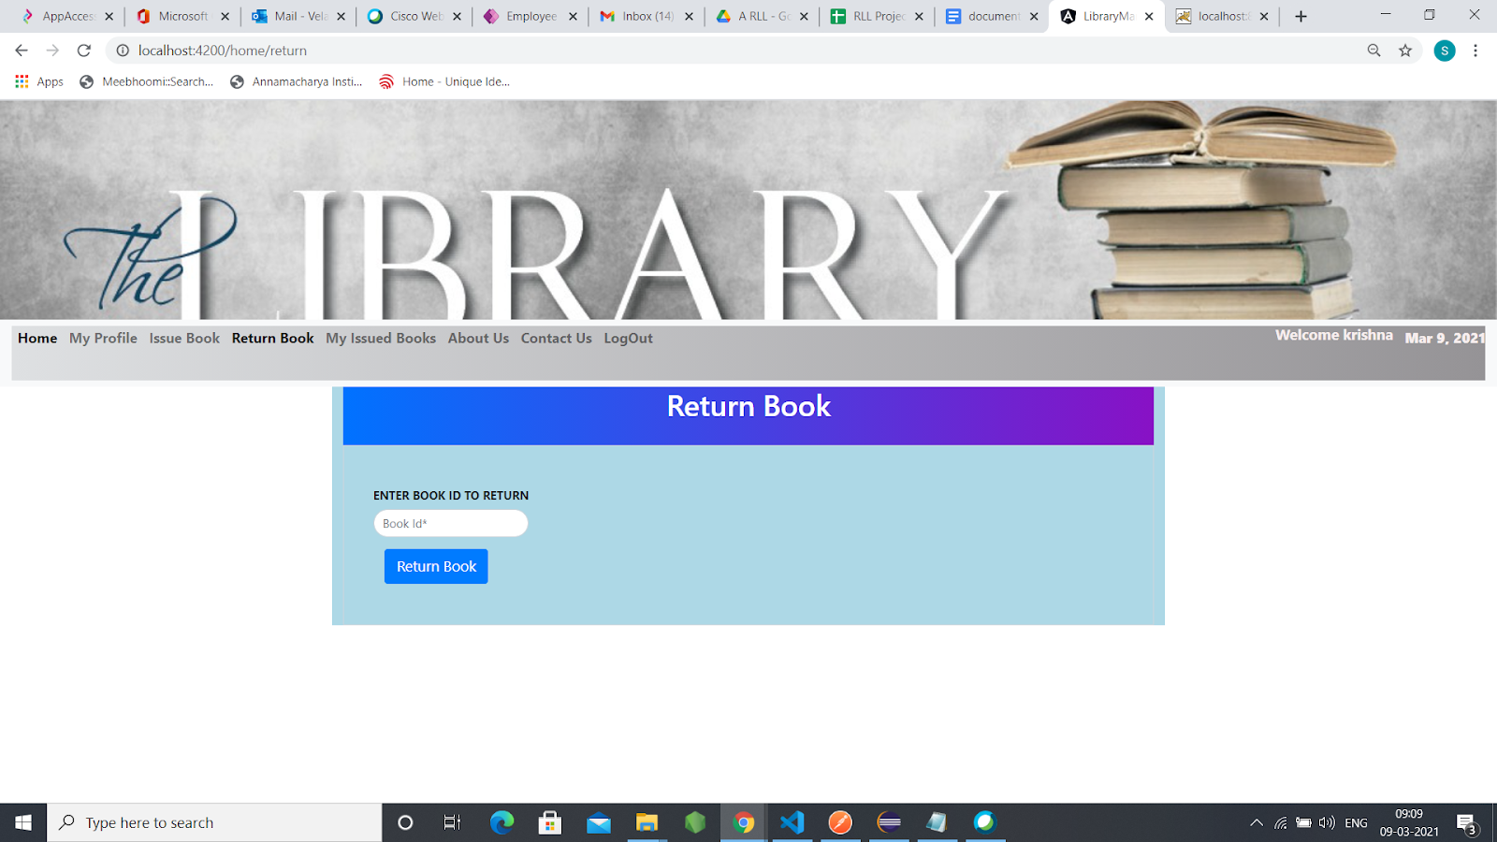

If a member wants to return a book then he can click on the “Remove Book” tab then it will be redirected to the return book page. For returning a book, the member has to enter the following credentials:

* Member Id: It should contain only digits
* Book Id: It contains both string characters and also digits

After entering the member id, book id, the member can return a book by clicking on the “Return Book” button.

**MY ISSUED BOOKS:**

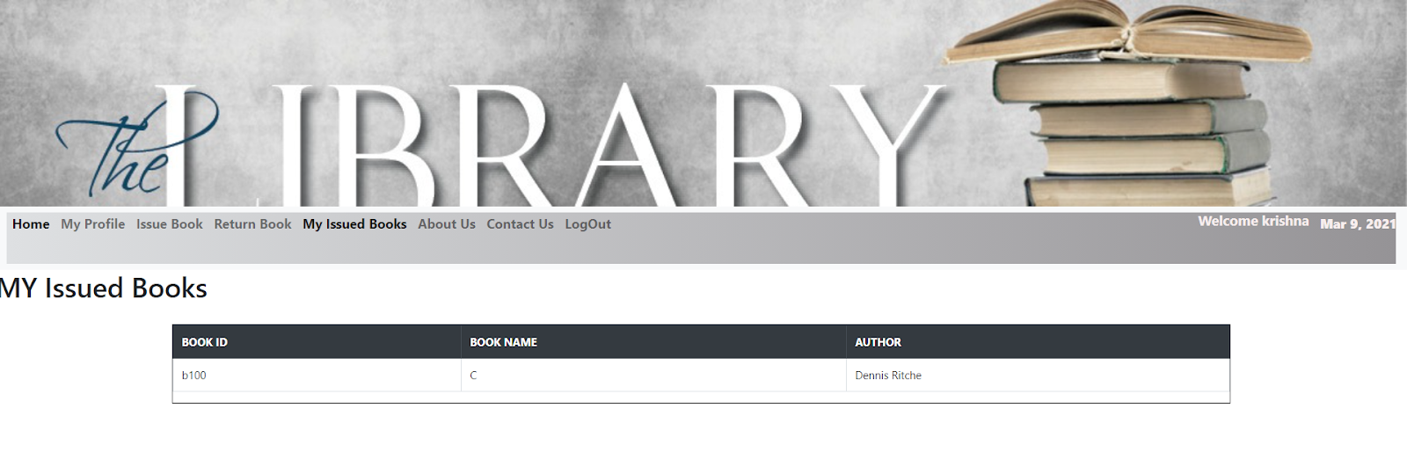

when the member click the my issued books tab, the user can see the issued books list in this page.

**ABOUT US:**

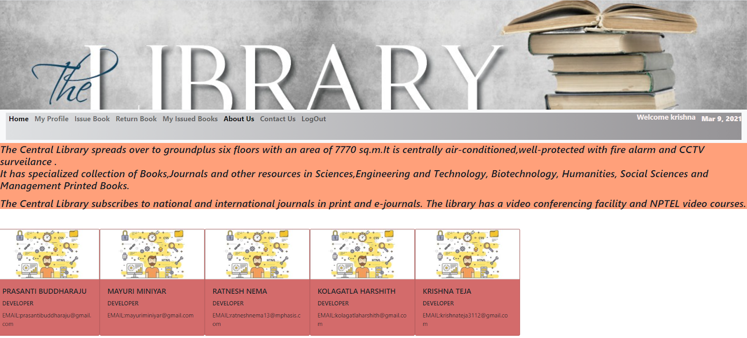

In “About Us” tab, there will be information regarding the library

**CONTACT US:**



 In “Contact Us” tab, there will be information like phone number, email, address of the library so that if the member have any query, the member can contact the library

**LOG OUT:**

When we access the “Log out” button the member can log out and it will be redirected to Member Login Page